Case 6-Afr-DR Congo-Pende-Female Statue-Wood and Raffa-19th c
Note: The Democratic Republic of the Congo (DR Congo) has been known as, in chronological order, the Congo Free State, Belgian Congo, the Republic of Congo-Léopoldville, the Democratic Republic of the Congo and the Republic of Zaire, before returning to its current name the DR Congo.
Note: The Kongo people (singular: Mukongo, pl. Bakongo) speak Kikongo, a Bantu language, who have lived along the Atlantic coast of Central Africa, in a region that, by the 15th century, was a centralized and well-organized Kongo Kingdom but is now a part of three countries: DR Congo, the Republic of the Congo and Angola.

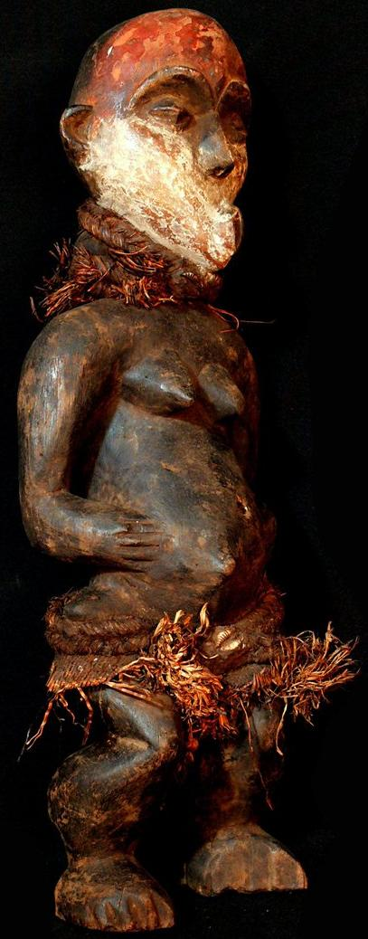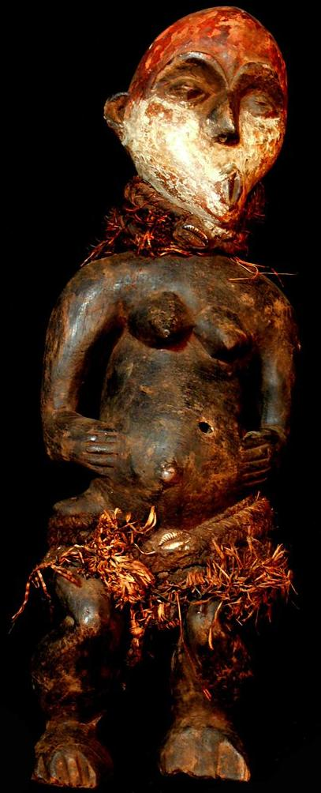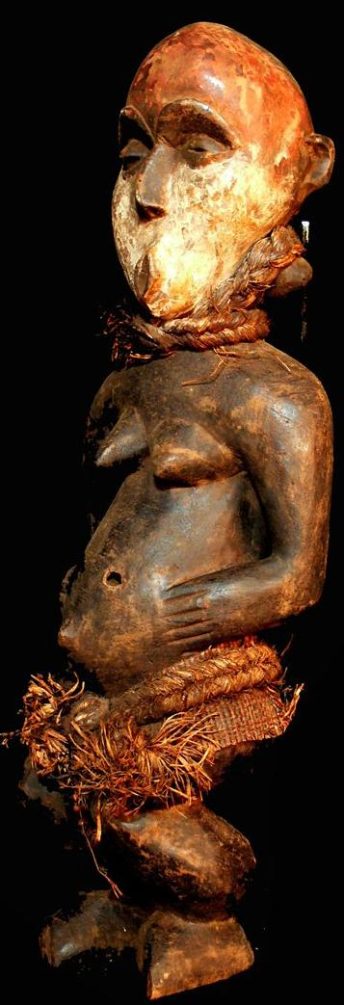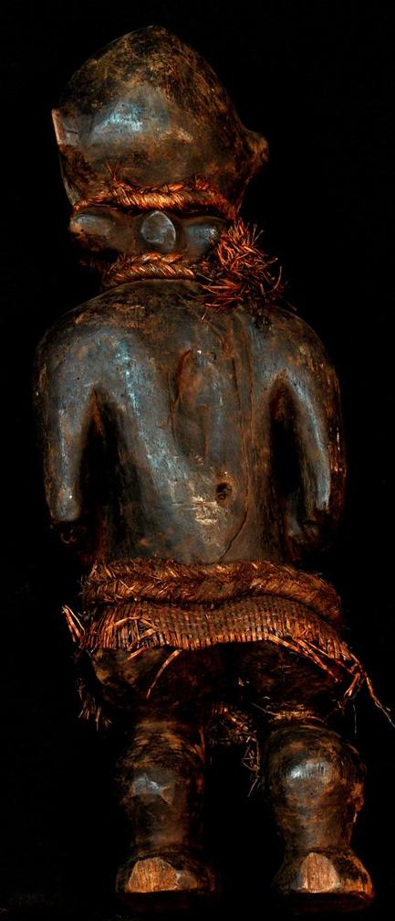
Figs. 1-4. Afr-DR Congo-Pende-Female Statue-Wood and Raffa-19th c
Case no.: AFRICAN MASKS
Accession Number:
Formal Label: Afr-DR Congo-Pende-Female Statue-Wood and Raffa-19th c
Display Description:
This Pende wooden statue of a female from DR Congo, western Kasai region, Tsbikapa zone, Kitangwa
Community, is dressed in a raffia skirt, wears a raffia necklace and a floral-shaped earring for the left ear. Her lower face is covered with kaolin, used as protection from the sun and as a sign of being pregnant. Her umbilical cord is everted and her beasts are small, which indicates that she is not lactating. However, her lower abdomen appears inflated as though she is pregnant.
The Pende, who are comprised of both eastern and western groups, govern themselves along extended family lineages rather than through chiefly authority. Before 1620 when the Kingdom of Lunda forced both groups to emigrate north, the Pende inhabited a strip between the Atlantic Ocean and the Cuanza River, in what is now Angola. Then, in 1885, the Chokwe put pressure on the eastern Pende to emigrate, but the creation of the Congo Free State under European colonials ended this forced removal.

LC Classification: N1099.C6
Date or Time Horizon:
Geographical Area:
Map:
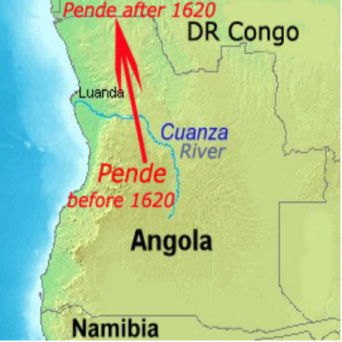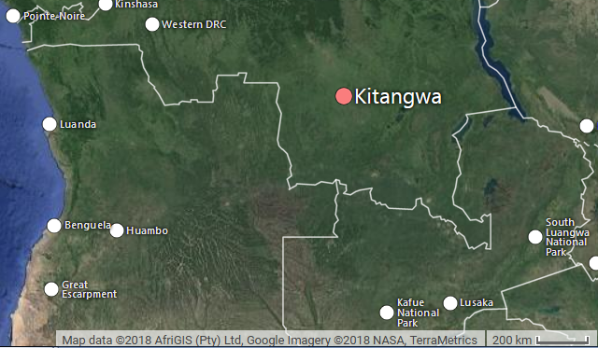
Fig. Map of Pende removal from between the Cuanza River and the Atlantic Ocean to modern DR Kongo after a base map https://upload.wikimedia.org/wikipedia/commons/6/6c/Cuanza.jpg
Fig. Google map of DR Congo showing location of Kitangwa.
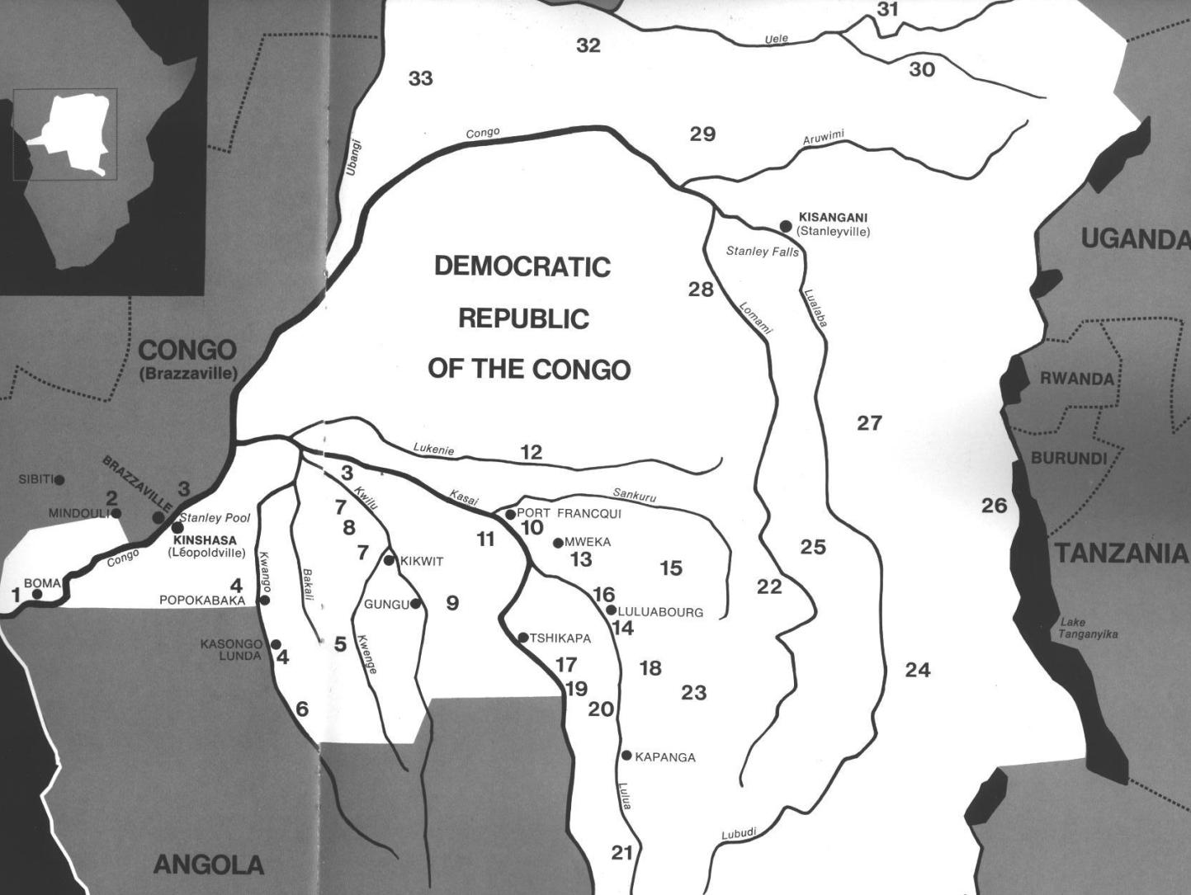
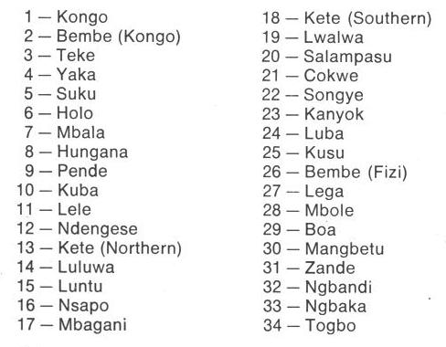
Fig. 1. Map of Kongo Cultures, West Central Africa. After Walker Art Center 1967. 9 is Pende.

GPS coordinates: 7° 46' 19.3" (7.772°) S, 24° 17' 44.9" (24.2958°) E
Cultural Affiliation: Pende, Central Bantu
Media: wood, raffia, kaolin, ferruginous earth
Dimensions: H 20.866 in
Weight: 2.52 pounds
Condition: original
Provenance: Kitangwa
Discussion:

References:
Adams, Monni. 1988. 8th century Kuba king figures, African Art 21(3): 32-38, 88.
Belepe, Bope. 1974. Etude socio-morphologique des masques Bwoom des Kuba: Memoire de licence en histoire. Lubumbashi: Université Nationale du Zaire.
Belepe, Bope. 1981. Les oeuvres plastiques Africaines comme documents d'histoire: Le cas des statues Royales Ndop des Kuba du Zaire, AfricaTervuren 25 (1): 9-17.
Binkley, D. 1987. Avatar of power: Southern Kuba masquerade figures in funerary context, Africa 57 (1).
Binkley, D. 1990. Masks, space and gender in southern Kuba initiation ritual, Iowa Studies in Art. Vol. 3, Art and Initiation in Zaire. Iowa City: The University of Iowa.
Brett-Smith, Sarah. 1983. “The Doyle Collection of African Art,” Record of the Art Museum, Princeton University, 42(2): 2+8-34.
Kuba du Zaire, Africa Tervuren 27(1): 9-17.
Binkley, D. 1987. Avatar of power: Southern Kuba masquerade figures in funerary context, Africa 57 (1).
Binkley, D. 1990. Masks, space and gender in southern Kuba initiation ritual, Iowa Studies in Art. Vol. 3, Art and Initiation in Zaire. Iowa City: The University of Iowa.
Claerhout, A. 1976. Two Kuba wrought-iron statuettes, African Art IX (4): 60-64.
Cornet, J. 1972. Art de l'Afrique Noire au pays du fleuve Zaire. Brussels: Arcade.
Cornet, J. 1975. Art from Zaire: 100 Masterworks from the National Collection. New York: African-American Institute.
Cornet, J. 1982. Art royal Kuba. Milan: Sipiel.
Ehret, Christopher. 2002. The civilizations of Africa: a history to 1800. Charlottesville: Virginia: University of Virginia Press.
Forbath, Peter. 1977. The River Congo. Boston: Houghton Mifflin.
Laman, Karl. 1953. The Kongo. 4. vols. Stockholm: Victor Pettersons.
MacGaffey, Wyatt. 1986. Religion and society in central Africa: the Bakongo of Lower Zaire. Chicago: University of Chicago Press.
MacGaffey, Wyatt. 1988. “Complexity, astonishment and power: the visual vocabulary of Kongo minkisi,” Journal of African Studies, (14:2), 188-203.
Martinez-Ruiz, Barbaro. 2013. Kongo Graphic Writing and other Narratives of the Sign. Philadelphia: Temple University Press.
Rosenwald, J. B. 1974. “Kuba king figure,” African Art, VII (3).
Schadeberg, Thilo. 1999. “Batwa: the Bantu name for the invisible people.” In Challenging Elusiveness: Central-African Hunter Gatherers in a Multidisciplinary perspective, ed. K. Beibrouck, S. Elders, and G. Rossel. Leiden: CNWS, 21-39.
Thompson, Robert Farris. 1978. “The Grand Detroit N’kondi,” Bulletin of the Detroit Institute of Arts 56 :4, 206-217.
Torday, E. and T. A. Joyce. 1911. « Notes ethnographiques sur les peuples communement appeles Bakuba, ainsi que sur les peuplades apparentees, les Bushoongo. » In Annales du Musee Royal du Congo Belge, Ethnographie et Anthropologic., serie III, tome II, fasc. 1. Brussels: Tervuren.
Vansina, Jan. 1955 “Initiation Rituals of the Bushong,” Africa 25(2): 138-153.
Vansina, Jan. 1964. Le royaume kuba. Tervuren: Musée royal de l'Afrique centrale.
Vansina, Jan. 1978. The children of Woot. A history of the Kuba peoples. Madison: University of Wisconsin Press/Dawson.
Vansina, Jan. 1984. Art History in Africa. London: Longman.
Van Wing, Joseph Hubert Leopold. 1941. Études Bakongo. II. Religion et magie. Institut royal colonial belge. Section des sciences morales et politiques. Mémoires, collection in-8°, t. IX, fasc. 1. Brussels: Desclée de Brouwer.
Van Wing, Joseph Hubert Leopold. 1959. Études Bakongo. Brussels: Desclée de Brouwer.
Walker Art Center. 1967. Art of the Congo. Minneapolis: Walker Art Center.

